**Assignment 3A**

Name: **Rushikesh Katte**

Roll Number: **23572**

Subject: **Web Technology**

To initialize git in the respective directory:

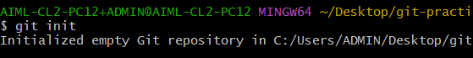

After that to add the files for staging:

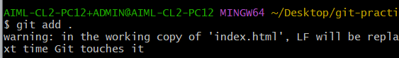

To Commit:

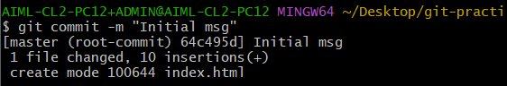

To add origin (link to the github repository) :



To select the main branch:



To push the code to the GitHub:



Result:

